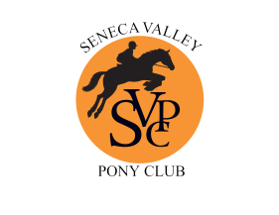
Seneca Valley Pony Club Reimbursement Form
c/o Sheila Jackson
12227 Galesville Drive
Gaithersburg, MD20878

Name: ________________________________________________________________________

Address: ________________________________________________________________________

________________________________________________________________________

Phone: _________________________ Email: _______________________________________

Date of Expense: ____________________________ Amount of Expense: _____________

Purpose of Expense: _________________________________________________________________

Seneca Valley Pony Club is an IRS recognized 501(c)3 organization. If you would prefer to make your reimbursement a charitable contribution, please check the following box and we will send you a letter for your taxes thanking you for your contribution.

- Check here to make this a charitable contribution.

Checklist for reimbursement (please include the following):
- Original receipt(s)
- Self-addressed, stamped envelope

Please arrange to mail the above items to the Treasurer, Sheila Jackson, 12227 Galesville Drive
Gaithersburg, MD20878.

All receipts for reimbursements should be received within 30 days after the event for which they are incurred. Requests for reimbursement received after this window will be considered a charitable contribution and we will mail you a letter for your taxes.

Please note Seneca Valley Pony Club is an IRS recognized 501(c)3 organization. As such, purchases associated with the organization should be tax-free. Copies of the tax exemption certificate are available through the SVPC Treasurer.
For Treasurer Use Only:
Account: ____________________________________________________________
Date: _____________ Check #: ____________

