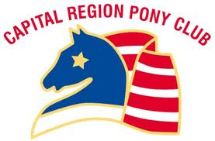

Entries are due October 24th
Information and Registration Instructions
2016 Eventing Clinic @ Loch Moy Farm
November 6, 2016
Loch Moy Farm ~ 1235 Park Mills Road ~ Adamstown, MD 21710

Hope to see you at the Fall 2016 Starter Horse Trials ~ November 6th
This clinic is open to ALL Capital Region Pony Club Members
INTENT OF CLINIC:
- To support our regional Pony Clubbers in their goal to learn the Eventing discipline.
- Utilize a quality venue to educate our Pony Clubbers in Eventing.
Clinicians: Capital Region Instructional Team
Rally Volunteers: Representatives from each participant
Registration: Go to www.themarylandhorsetrials.com
Go to Fall 2016 Starter Horse Trials on November 6th
Complete the 2016 Fall Starter Horse Trial Entry Form & additional forms
Pay fees associated with the Starter HT. See entry form for more details.

Please e-mail Nicole Potter @ pottenic@gmail.com once entry is complete for the planning of our clinic.

Go Capital Region!

